5th Euro-Asian Pulsed Power Conference EAPPC2014

September 8-12, 2014, Kumamoto University, Kumamoto, Japan

**Application Form for Exhibit, Financial Support with Ad**

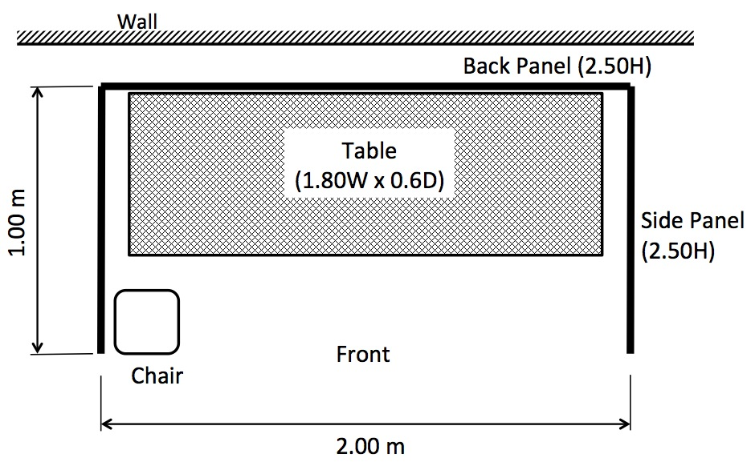**Exhibit:**

Fee: JPY50,000 per booth

Space: 2.0 m breadth x 1.0 m depth x 2.5 m height

Table: 1.8 m length x 0.6 m width x 0.7 m height

Name Plate: 0.3 m x 0.9 m

Equipment: Lighting, AC Power (100 V,10 A), Chairs

Exhibit Period: Sep. 9 (Tue.) 8:00 am – 11 (Thu.) noon

Setup: Sep. 8 (Mon.)

Removal: Sep. 11(Thu.) or 12(Fri.)

**Charge for Explainers:**

Free of charge (no lunch ticket, no banquet ticket)

A lunch ticket (JPY2,000 for 3 days from Sep. 9 to 11) and a banquet ticket (JPY15,000) are available independently.

Persons having presentations in the technical session need to register at the WEB site as regular participants. http://www.ipps.kumamoto-u.ac.jp/eappc2014/

**Financial Support with Advertisement:**  Fee: JPY20,000

Company name and logo appear on the WEB site, program book and conference bag. Also a sheet of flyer of your products can be handed out to the all participants. These are included in the Exhibition.

**Method of Payment:** Bank transfer. The detail will be notified later.

**Fill out the following items and e-mail this sheet to** **eappc2014@cs.kumamoto-u.ac.jp.**

**Exhibit: Yes or No**  (chose either)

**Number of Booths:** (number)

**Number of Explainers:** (number)

**Financial Support with Advertisement** (included in Exhibit)**: Yes or No**  (chose either)

**Reception Tickets** (on Sep. 8. free of charge)**:** (number)

**Lunch Tickets** (Sep. 9 to 11 (3 days), JPY2,000/person)**:** (number)

**Banquet Tickets** (on Sep. 11, JPY15,000/person)**:** (number)

**Total JPY**

**CONTACT INFORMATION**

**Company Name:**

**Person in Charge:**

**E-mail Address:**

**Telephone:**

**Name(s) of All Explainers (company name if agency):**

**Requests?**

**SIGNATURE DATE**